Installing the Anaconda Environment for the „Remote Sensing SS2020“ practice

If you are on this stage, it means that you correctly installed Miniconda on your computer. If you still have troubles doing so, I can recommend you to check this [tutorial](https://katiekodes.com/setup-python-windows-miniconda/), on the section “*Installing Miniconda & running a Python program”.*

Once you know that conda (from Miniconda) was properly installed, you can run a short check.

1. Opening the „Anaconda Powershell Prompt“:

Under Windows 10 the prompt is most conveniently found in the searchbar next to the startbutton.

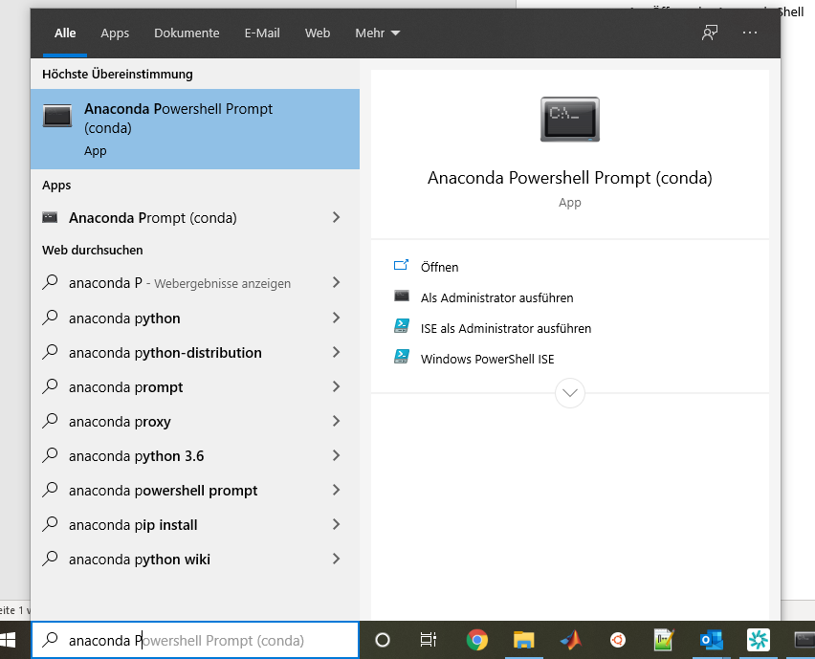

Image 1 Windows 10 searchbar

NOTE:

1. Conda installation command:

The opening window understands and executes conda commands.

Now we are going tell it to install our practice environment, for this we will need to specify where we saved it. In my case it is stored on the C drive in a folder called “envs” („C:\envs“). You can adapt this path depending where you want to store your environments.

This makes the following command:

conda env create -f C:\envs\rio.yml y

In case this is not your first attempt first remove the environment from previous attempts:

conda remove --name --all

conda remove -n rio –all (to eliminate only rio)

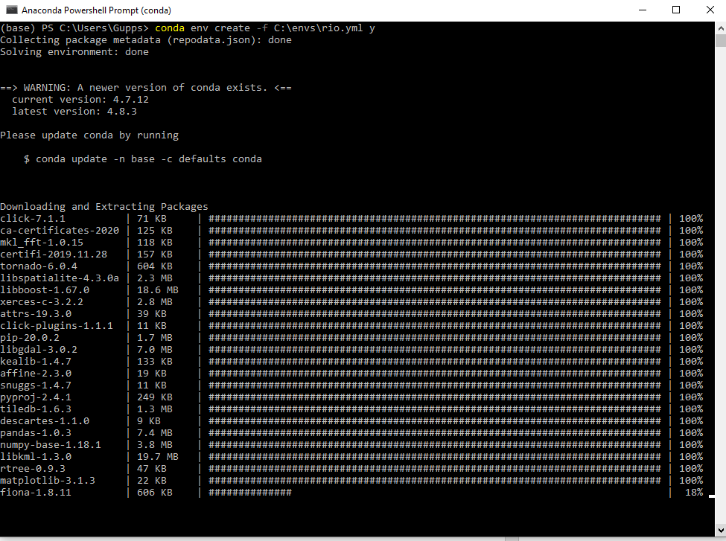

Image 2 Anaconda Powershell Prompt

This process should take about 2-3 minutes on a normal machine (it might be fast or slow depending on your hardware capacity).

1. Run conda env list on the Anaconda Command Prompt. This command will give you a list of the packages installed by Miniconda.
2. Another way of testing if the packages were properly installed, is to try to install them again. First activate the environment with conda activate rio. Second, type conda install jupyter scikit-learn rasterio in the Anaconda Command Prompt. If the package “scikit” was correctly installed you will get a message similar to “requirement already satisfied”.

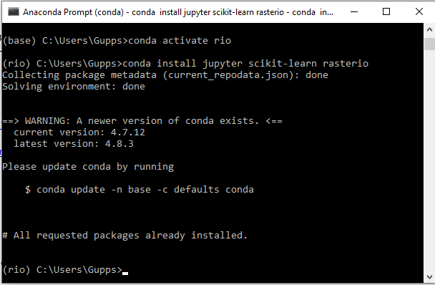

Image 3 Performing a check of the environment in the Anaconda Powershell Prompt

1. Now you have installed Miniconda and checked that it was working properly. The next step is to choose a platform from where you can use Python. There are many of these platforms or [IDE](https://en.wikipedia.org/wiki/Integrated_development_environment)s to choose from. On the FE1 course, we will use Jupyter for this.

Congratulations!! Now you’re all set!

See the next Page to find out how to use your environment.

How to Start Jupyter Notebooks

1. Open the „Anaconda Powershell Prompt“
2. Activate your environment with the following command:

conda env activate rio.yml

1. Start Jupyter by typing the command*:*

Jupyter notebook

1. You will find a web page that starts with: <http://localhost:8888/> (best use with Chrome or Firefox)

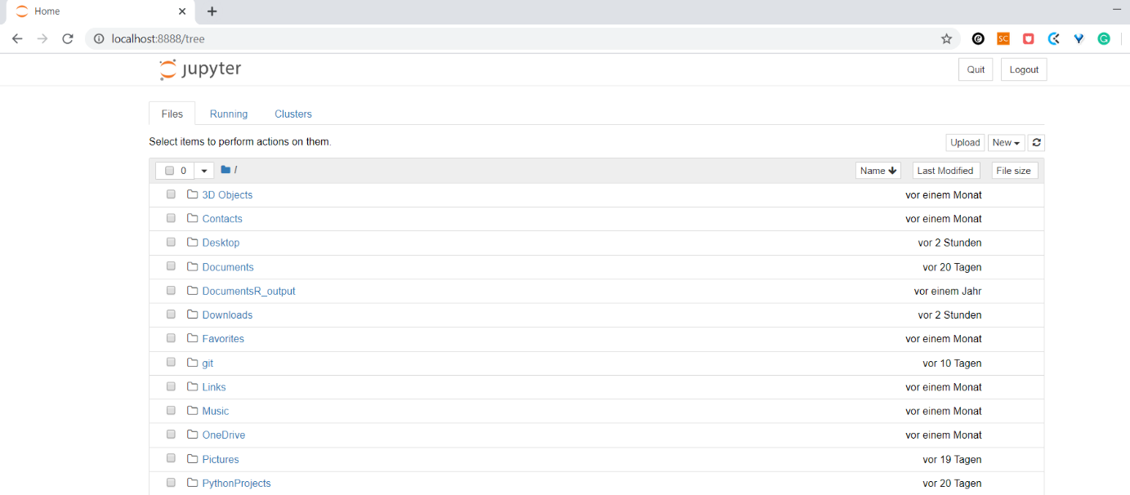

Image 4 Jupyter view

1. This page shows all the folders that you have on your computer in "C:\Users\your_username". Navigate to the folder where you have all the data stored for this practice. In my case, I stored the files for this practice under "C:\Users\your_username \PythonProjects\practices_fe1_ss2020\scripts"

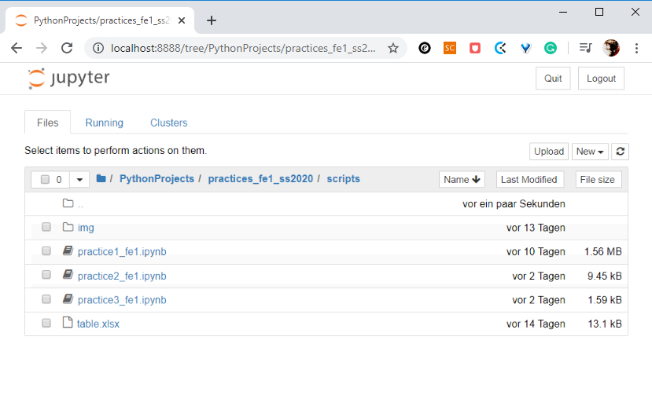

Image 5 Notebooks on Jupyter

1. Congratulations!! Now you are all set! Click on the *.ipynb file to open the practice. See you on classes.

**More information:**

How to install Miniconda and Jupyter: <https://www.codecademy.com/articles/install-python3>

Introduction to Jupyter: <https://www.youtube.com/watch?v=HW29067qVWk>